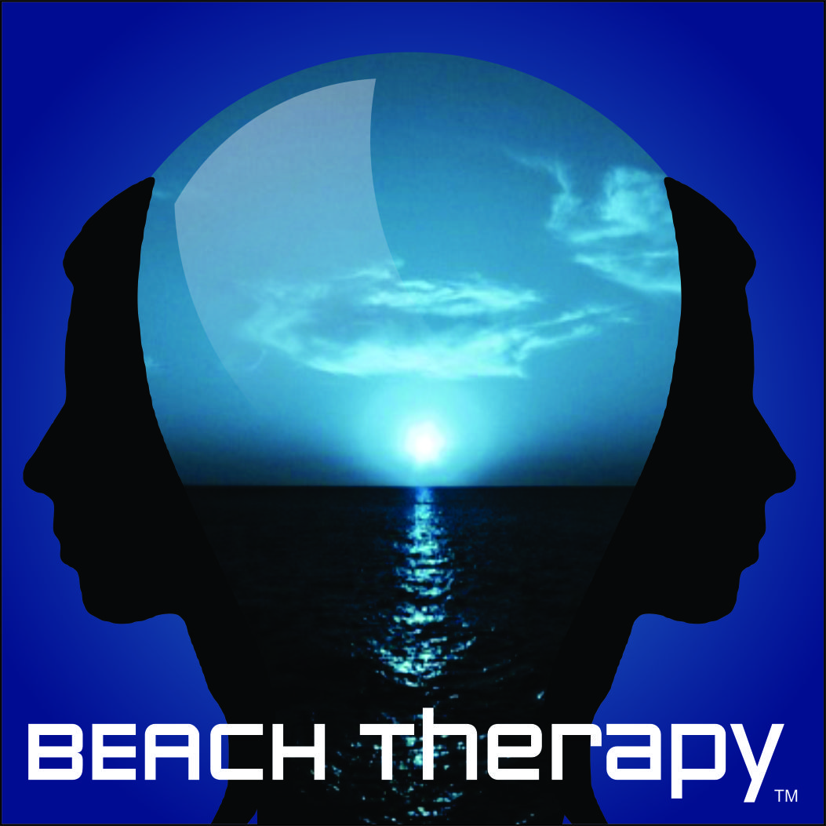

Price Sheet and Payment Agreement

- 60-minute CBT,EMDR or Couples session: $195
- 90-minute CBT, EMDR or Couples session: $255
- Free 15-minute initial phone consultation *

I ________________ understand that it is my responsibility to pay fees for counseling services provided by Beach Therapy Inc.

______________________________________ __________
Signature Date

- An initial 15 minute phone consultation is offered prior to the start of services

